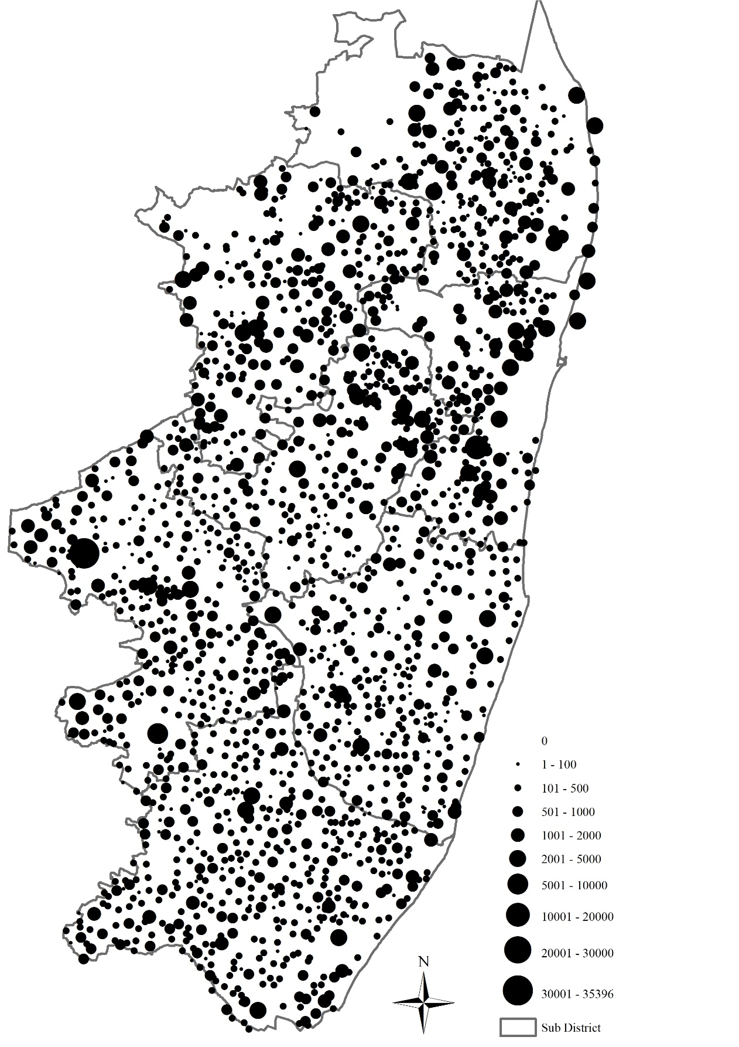
0

20 Km

Map 1-5. Populations of Hamlets in Chingleput in 1871.
Source: Census, Statement of Population of 1871 in Each Village of the Chingleput District arranged according to Area, Caste, and Occupation, Madras, 1874.

