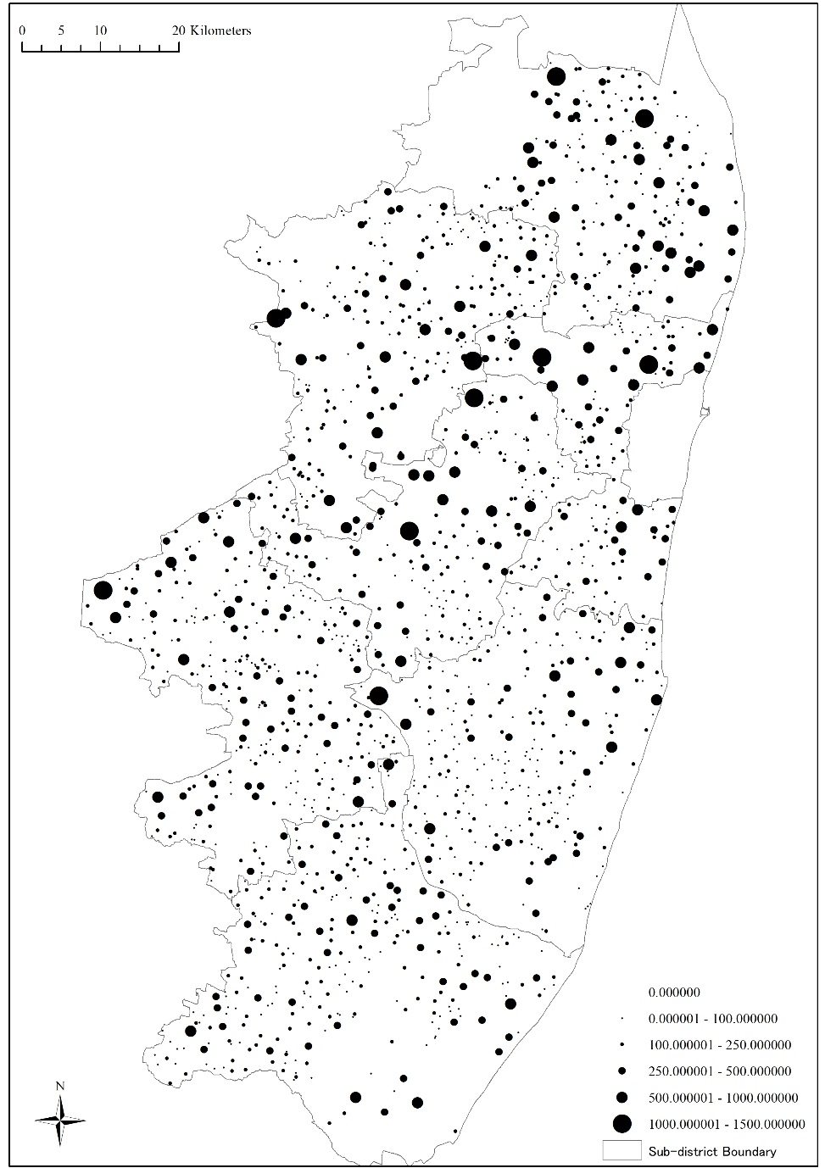
(in acre)
Map 1-2. Cultivated Land in Chingleput in 1871

Source: Census, Statement of Population of 1871 in Each Village of the Chingleput District arranged according to Area, Caste, and Occupation, Madras, 1874.

