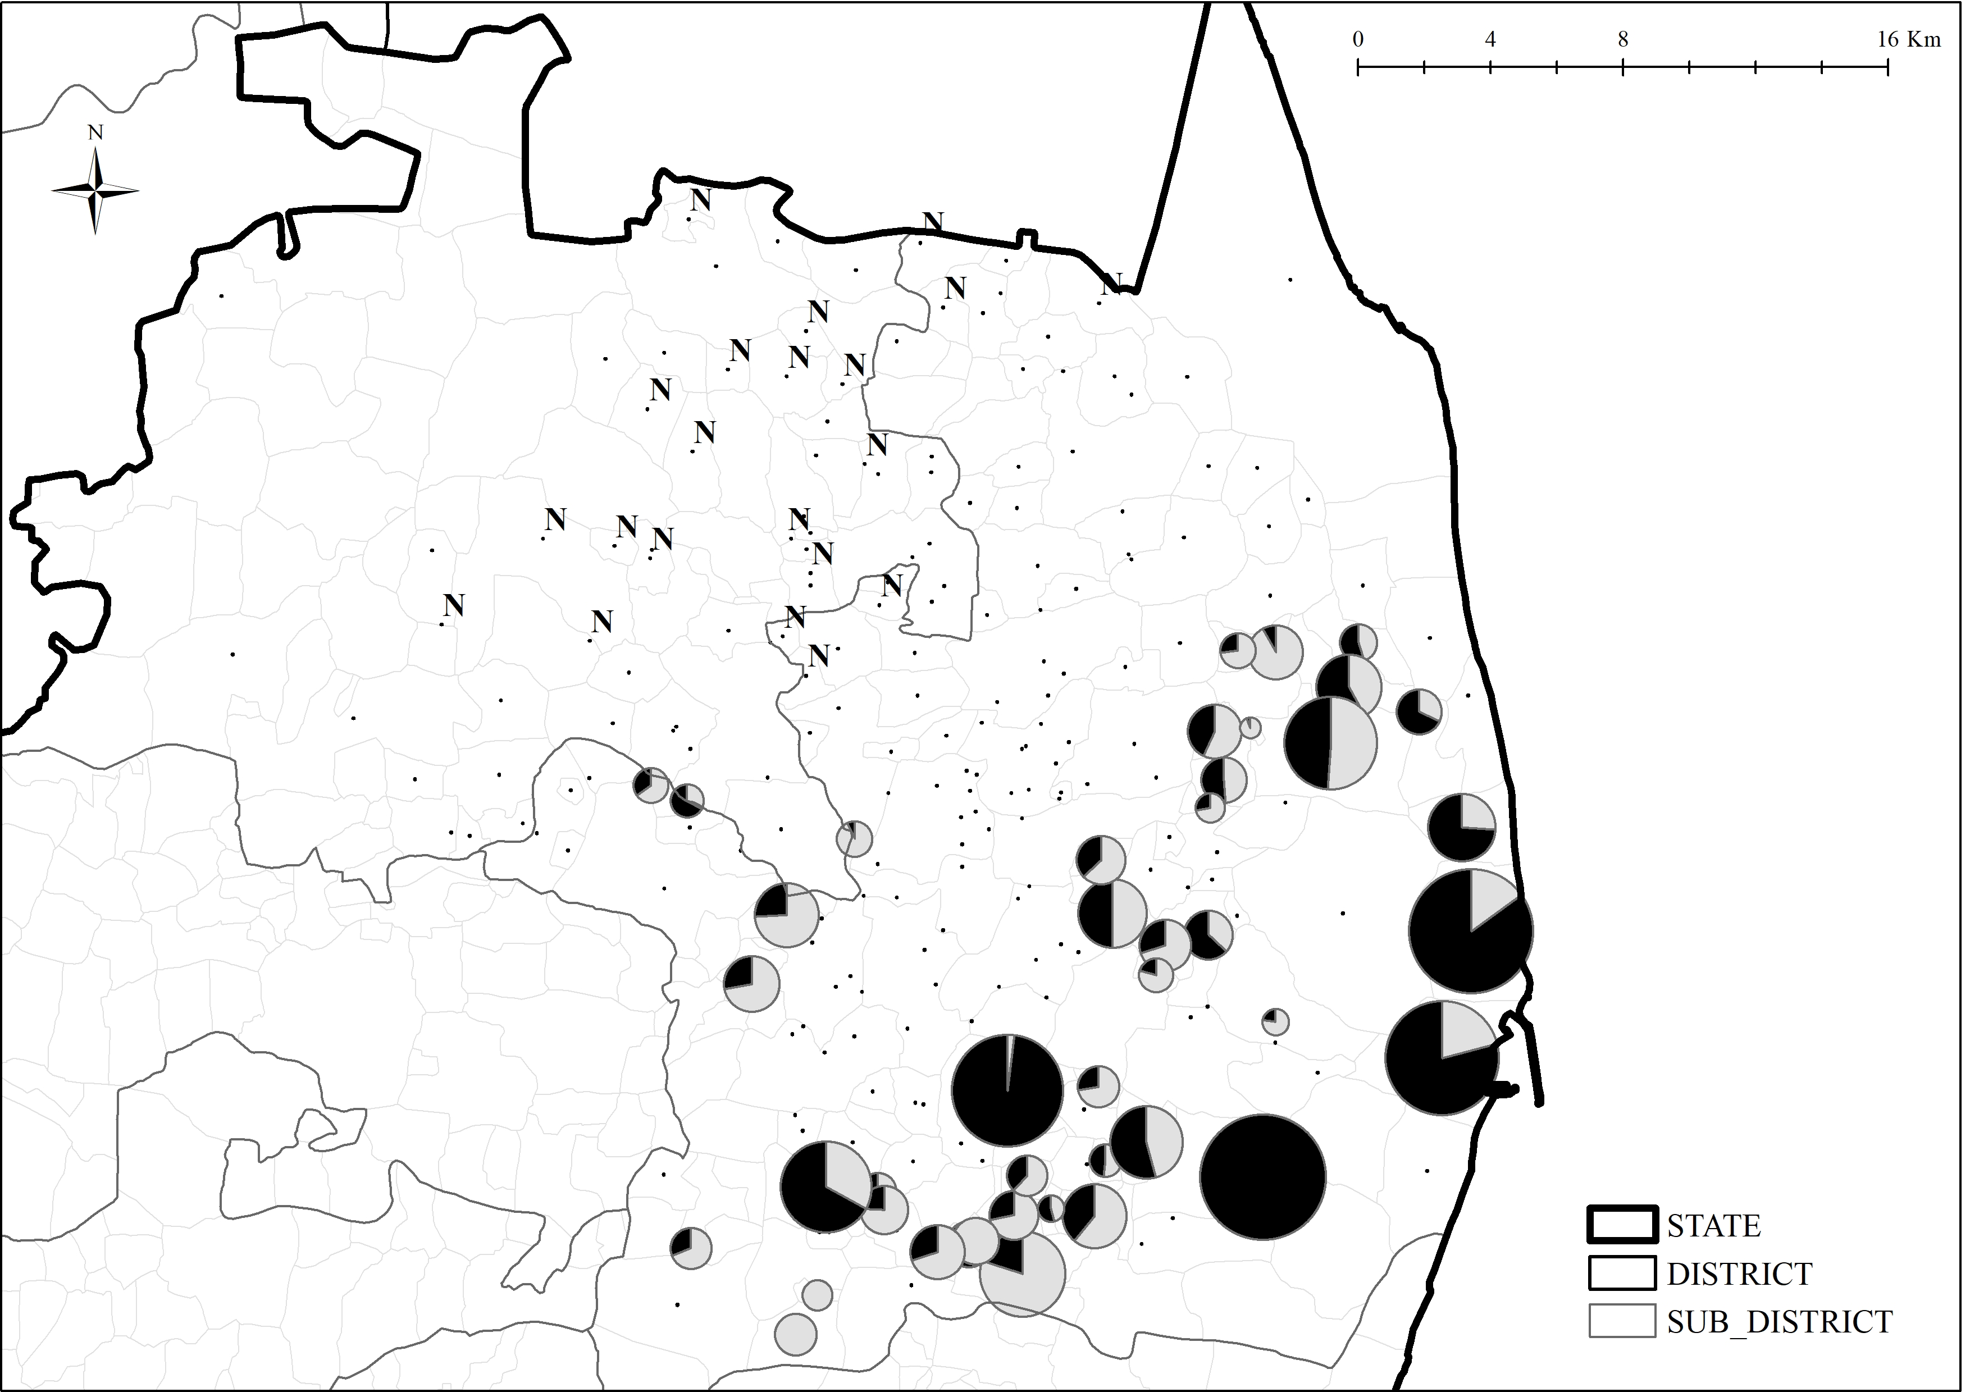
Map 1-3. Composition of Mirasidar and Non-Mirasidar Landholding in Ponneri Villages

Notes.
- – Landholding by Mirasidars - Landholding by Non-Mirasidar
- N – Non-Mirasi Villages
Source: Settlement Registers of Ponneri Villages in 1877

