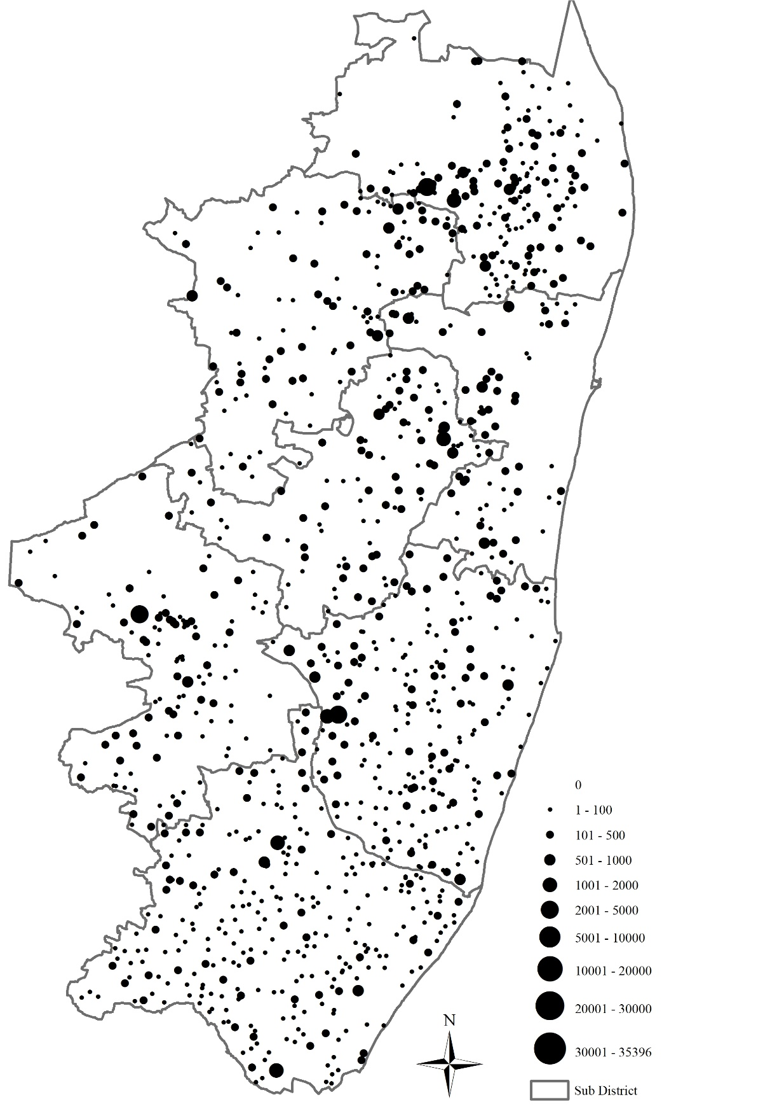
0

20 Km

Map 1-4. Populations of Hamlets in Chingleput in 1801.
Source: Zamindari Statement, Statement relating to Permanent Settlement of Jagir forwarded as Enclosures to Mr. Greenway’s Letter, 29 March, 1801 (Permanent Settlement Records, vols. 20–22)

